**Project Report Format**

1. **INTRODUCTION**
   1. Project Overview
   2. Purpose
2. **LITERATURE SURVEY**
   1. Existing problem
   2. References
   3. Problem Statement Definition
3. **IDEATION & PROPOSED SOLUTION**
   1. Empathy Map Canvas
   2. Ideation & Brainstorming
4. **REQUIREMENT ANALYSIS**
   1. Functional requirement
   2. Non-Functional requirements
5. **PROJECT DESIGN**
   1. Data Flow Diagrams & User Stories
   2. Solution Architecture
6. **PROJECT PLANNING & SCHEDULING**
   1. Technical Architecture
   2. Sprint Planning & Estimation
   3. Sprint Delivery Schedule
7. **CODING & SOLUTIONING (Explain the features added in the project along with code)**
   1. Feature 1
   2. Feature 2
   3. Database Schema (if Applicable)
8. **PERFORMANCE TESTING**
   1. Performace Metrics
9. **RESULTS**
   1. Output Screenshots
10. **ADVANTAGES & DISADVANTAGES**
11. **CONCLUSION**
12. **FUTURE SCOPE 13. APPENDIX** Source Code

GitHub & Project Demo Link

**1. INTRODUCTION**

**1.1 Project Overview**

TrafficTelligence is an advanced traffic volume estimation system leveraging the power of Artificial Intelligence (AI) and Machine Learning (ML) to address the escalating issues associated with traffic congestion. The surge in the number of vehicles, coupled with a decline in the use of public transport, has led to an urgent need for innovative solutions to monitor and manage traffic effectively. TrafficTelligence aims to provide a comprehensive and accurate analysis of traffic volume at various locations, enabling governments to make informed decisions regarding infrastructure development, road construction, and the enhancement of multi-channel connectivity.

**1.2 Purpose**

The primary purpose of TrafficTelligence is to utilize AI-ML models to measure and predict traffic volume with a high level of precision. By doing so, the system aims to identify traffic patterns, potential violations of traffic rules, and provide early alerts for severe traffic conditions. The objective is to equip authorities with valuable insights to proactively address traffic-related issues, optimize urban planning, and enhance overall traffic management.

**2. LITERATURE SURVEY**

**2.1 Existing Problem**

The existing problem revolves around the escalating challenges posed by traffic congestion. The increase in the number of vehicles, coupled with a decrease in the utilization of public transportation, has resulted in traffic-related issues such as delays, accidents, and environmental concerns. Traditional traffic management systems often lack the ability to provide real-time insights and predictions, leading to inefficient resource allocation and suboptimal decision-making.

TrafficTelligence seeks to address these challenges by introducing advanced ML algorithms capable of accurately estimating traffic volume. This involves the analysis of historical data, real-time traffic patterns, and the integration of predictive models to anticipate future traffic conditions.

**2.2 Problem Statement Definition**

The problem at hand is to develop ML algorithms that can accurately predict traffic volume with a level of precision that reduces errors in projected datasets. The system should be capable of analyzing historical traffic data, identifying patterns, and adapting to dynamic changes in traffic conditions. The goal is to create a reliable model that not only predicts traffic volume but also provides early alerts for severe traffic situations, enabling timely intervention and preventive measures. TrafficTelligence aims to contribute to the optimization of traffic management systems and facilitate better decision-making for urban planning and infrastructure development.

**Ideation Phase**

**Empathize & discover**

|  |  |
| --- | --- |
| Date | 19 September 2023 |
| Team ID | **593090** |
| Project Name | |  | | --- | | TrafficTelligence: Advanced Traffic  Volume Estimation with Machine Learning | |  | |
| Maximum Marks | 4 Marks |

**Empathy Map Canvas:**

The Empathy Map Canvas is a visual tool used in design thinking and customer experience design to understand and empathize with the target audience or users. It is a collaborative exercise that helps teams gain a deeper understanding of the people they are designing for by exploring their thoughts, feelings, actions, and aspirations.

The Empathy Map is particularly useful in the early stages of the design process to create a user-centred focus and to ensure that the resulting product or service addresses the real needs and experiences of the target audience. It promotes empathy, which is essential for creating solutions that genuinely meet the users' needs and expectations.

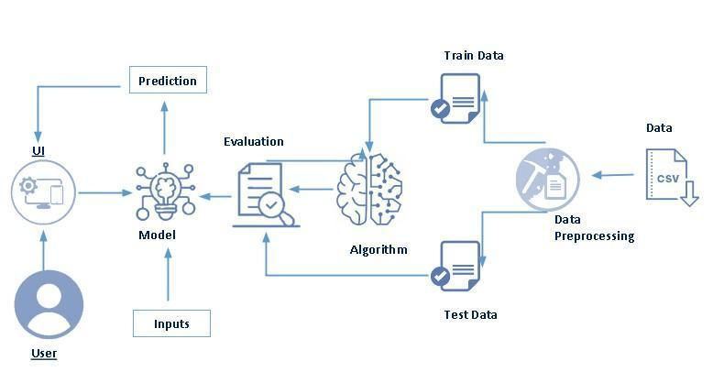

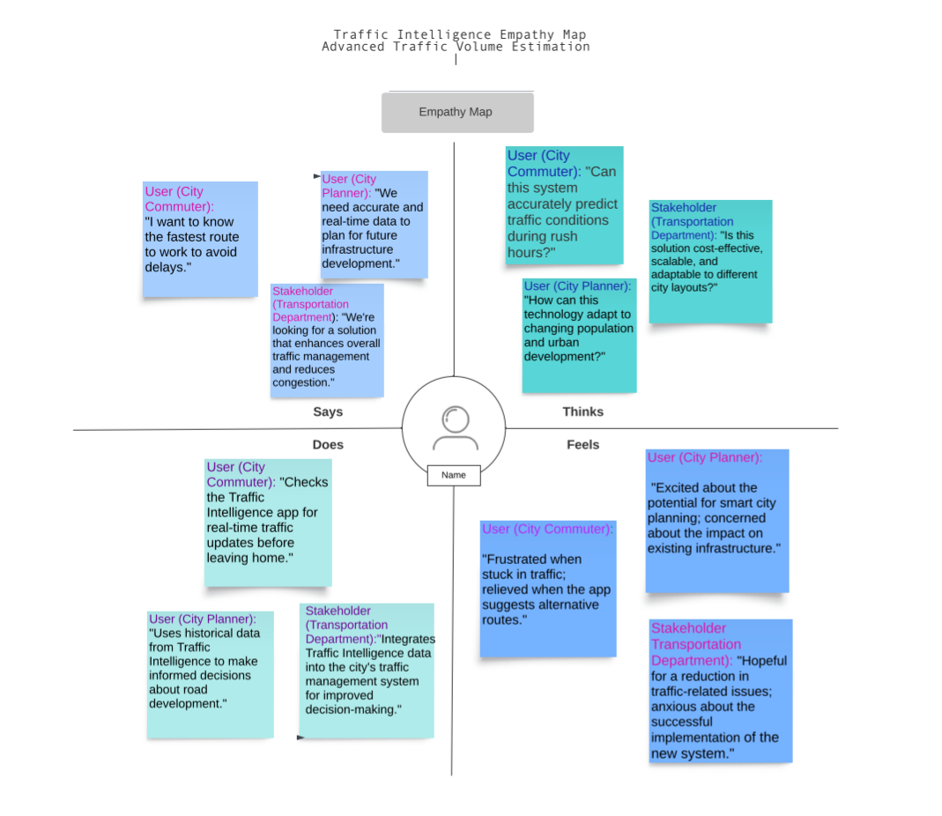

An Empathy mapping canvas includes:

**Users**:

Main user are all citizens.

**Stakeholders:**

there are many stake holders, like:

1.students.

2.employees.

3.senior citizens.

4.childrens.

5.worker

**Activities:**  
The activities which are carried out: -

1.walking.

2.driving.

3.towing vehicles. Etc

Now,

The Empathy Map Canvas typically consists of **four quadrants (Says , Thinks ,Does , Feels)** , each focusing on a different aspect of the user's experience:

Here's an example of how you might fill out each quadrant:

**1. Says:**

User (City Commuter): "I want to know the fastest route to work to avoid delays."

User (City Planner): "We need accurate and real-time data to plan for future infrastructure development."

Stakeholder (Transportation Department): "We're looking for a solution that enhances overall traffic management and reduces congestion."

**2. Thinks:**

User (City Commuter): "Can this system accurately predict traffic conditions during rush hours?"

User (City Planner): "How can this technology adapt to changing population and urban development?"

Stakeholder (Transportation Department): "Is this solution cost-effective, scalable, and adaptable to different city layouts?"

**3. Does:**

User (City Commuter): "Checks the Traffic Intelligence app for real-time traffic updates before leaving home."

User (City Planner): "Uses historical data from Traffic Intelligence to make informed decisions about road development."

Stakeholder (Transportation Department): "Integrates Traffic Intelligence data into the city's traffic management system for improved decision-making."

**4. Feels:**

User (City Commuter): "Frustrated when stuck in traffic; relieved when the app suggests alternative routes."

User (City Planner): "Excited about the potential for smart city planning; concerned about the impact on existing infrastructure."

Stakeholder (Transportation Department): "Hopeful for a reduction in traffic-related issues; anxious about the successful implementation of the new system."

**Ideation Phase**

|  |  |
| --- | --- |
| Date | 19 September 2023 |
| Team ID | **593090** |
| Project Name | |  | | --- | | TrafficTelligence: Advanced Traffic  Volume Estimation with Machine Learning | |  | |
| Maximum Marks | 4 Marks |

**Brainstorm & Idea Prioritization Template:**

A Brainstorm & Idea Prioritization Template is a structured document or visual representation used to facilitate the brainstorming process and prioritize ideas generated during a brainstorming session. This template helps teams or individuals organize their thoughts, evaluate different concepts, and decide which ideas are most promising or feasible.

**Step-1: Team Gathering, Collaboration and Select the Problem Statement**

Every day, there are more and more traffic jams on urban networks due to rising traffic demand and sharply decreasing vehicle speeds, which prolong traffic lines and significantly impede traffic flow by creating holdups.

Such situations highlight towards the drawback such as

1. Increase in pollution
2. Wear and tear of vehicles
3. Delays may result in late arrival etc

The traffic environment is becoming worse and worse, to unravel this problem and to assist our society, we've chosen our topic as traffic volume estimation

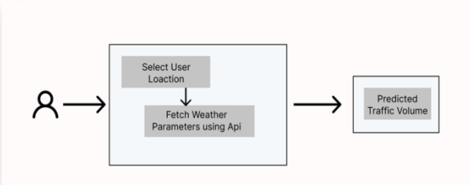

**Step-2: Brainstorm, Idea Listing and Grouping**

Now, the question arises of how to improve the capacitor y of the road network. To solve this *problem* the first solution that occurs to most of us is to build more highways, expanding the number of lanes on the road. However, according to the study done by scholars, expanding the road capacity will cause more serious traffic conditions.

This study aims to find a traffic volume predictor appropriate for practical applications. In terms of power consumption and computation cost, this predictor needs to be precise. In our pursuit of such a predictor, we have incorporated the following contributions: We compare existing schemes to seek out their effectiveness for real-time applications.

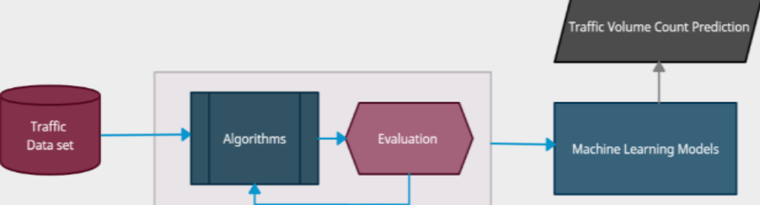

**Step-3: Idea Prioritization**

To make this existing system more efficient and enforce traffic environment for efficient and accurate transportation, which may help us better arrange transportation resources, disperse the traffic flow before it's overloaded, and even provide more abundant on-road entertainment. Where one such need arises towards the prediction of traffic volume count. Importance of traffic volume: • Better implies for advancement of infrastructures. • Provides way better implies to utilize streets • Accurate activity volume forecast can help course arranging, and relieve activity congestion. • All of these planning will also help the government and rest of bodies

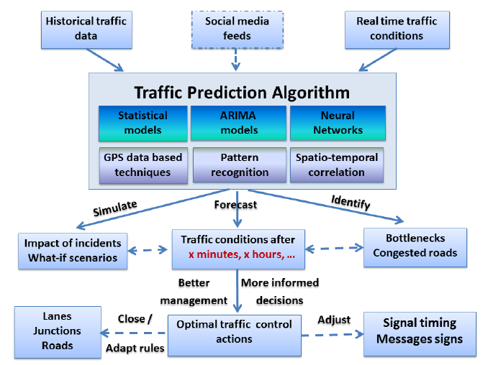  
  
  
  
**REQUIREMENT ANALYSIS: -**

**Functional Requirement: -**

**1. Data Collection and Preprocessing:**

1.1 Real-time Data Ingestion:

- The system should be capable of collecting real-time traffic data from various sources, including sensors, cameras, and other relevant devices.

1.2 Data Cleaning and Preprocessing:

- Implement data cleaning algorithms to handle missing or erroneous data, ensuring the accuracy and reliability of the input data.

1.3 Data Integration:

- Integrate data from different sources into a unified format for analysis, ensuring compatibility and consistency.

2. Traffic Volume Estimation:

2.1 ML Model Development:

- Develop machine learning models capable of accurately estimating traffic volume based on historical and real-time data.

2.2 Model Training:

- Implement a training mechanism for the ML models using labeled datasets to enhance accuracy and responsiveness.

2.3 Adaptive Learning:

- Enable the system to adapt and learn from changes in traffic patterns over time, ensuring continuous improvement in prediction accuracy.

2.4 Dynamic Volume Prediction:

- Provide real-time predictions of traffic volume, considering dynamic factors such as special events, holidays, and weather conditions.

**5.PROJECT DESIGN: -**

**User Stories**

Use the below template to list all the user stories for the product.

|  |  |  |  |  |  |  |
| --- | --- | --- | --- | --- | --- | --- |
| **User Type** | **Functional**  **Requirement**  **(Epic)** | **User Story Number** | **User Story / Task** | **Acceptance criteria** | **Priority** | **Release** |
| Customer  (Laptop user) | Project setup &  Infrastructure | USN-1 | USN-1 Set up the development environment with the required tools and frameworks to start the advanced traffic volume detection project. | Showing the approximately accurate traffic volume. | High | Sprint-1 |
| Administrator | development  environment | USN-2 | USN-2 Gather a diverse dataset of data containing traffic volume on different holiday (Diwali, Durga Puja, Chath Puja) for training the machine learning model. | The day is working or holiday | High | Sprint-1 |
| Administrator | Data collection | USN-3 | USN-3 Preprocess the collected dataset by removing the outlier and splitting it into training and testing or validation sets. | Data does not have any null values and does not contain outlier | High | Sprint-2 |
| Administrator | data preprocessing | USN-4 | USN-4 Explore and evaluate different machine learning architectures to select the most suitable model for advanced traffic volume detection. | The model is giving a higher accuracy | Medium | Sprint-2 |
| Administrator | model development | USN-5 | USN-5 train the selected machine learning model using the preprocessed dataset and monitor its performance on the testing or validation set. | The model is correctly predicting the traffic volume. | High | Sprint-3 |
| Administrator | Training | USN-6 | USN-6 implement accuracy improving techniques like hyperparameter tuning to improve the model's robustness and accuracy. | The accuracy is improved or the model is correctly predicting the traffic volume. | medium | Sprint-3 |
| (Web user) | model deployment & Integration | USN-7 | USN-7 deploy the trained machine learning model as an API or web service to make it accessible for advanced traffic volume detection.. integrate the model's API into a user-friendly web interface for users to upload images and receive traffic volume detection results. | The traffic volume for a particular day is shown. | medium | Sprint-4 |
| Customer Care Executive | Testing & quality assurance | USN-8 | USN-8 conduct thorough testing of the model and web interface to identify and report any issues or bugs. fine-tune the model hyperparameters and optimize its performance based on user  feedback and testing results. | The model is accurate in predicting the traffic volume. | medium | Sprint-5 |

**Project Design Phase-I**

**Proposed Solution Template**

|  |  |
| --- | --- |
| Date | 19 September 2023 |
| Team ID | **593090** |
| Project Name | |  | | --- | | TrafficTelligence: Advanced Traffic  Volume Estimation with Machine Learning | |  | |
| Maximum Marks | 2 Marks |

**Proposed Solution Template:**

Project team shall fill the following information in proposed solution template.

|  |  |  |
| --- | --- | --- |
| **S.No.** | **Parameter** | **Description** |
| 1. | Problem Statement (Problem to be solved) | Urban centres worldwide are grappling with escalating traffic congestion, leading to increased travel times, fuel consumption, and environmental pollution. Conventional methods of  traffic volume estimation often fall short in providing real-time and accurate insights necessary for effective traffic management. The challenge is to develop an advanced traffic volume estimation system leveraging machine learning (ML) techniques that can handle the complexity of urban traffic patterns, adapt to dynamic conditions, and contribute to the optimization of urban mobility. |
| 2. | Idea / Solution description | Our proposed solution is an innovative and advanced traffic volume estimation system that leverages the power of machine learning (ML) to transform urban mobility management. This system is designed to address the complexities of dynamic traffic patterns, provide real-time insights, and contribute to the optimization of traffic flow in urban environments. |
| 3. | Novelty / Uniqueness | Introduced a novel approach that generates predictive embeddings specifically designed for urban traffic. Use techniques such as graph embeddings or spatial-temporal embeddings to capture complex relationships between different road segments, intersections, and time intervals. Designed the training process to be energy-efficient, incorporating techniques such as model compression or quantization. This ensures that the system can be deployed sustainably, aligning with environmental and energy conservation goals. |
| 4. | Social Impact / Customer Satisfaction | The potential to bring about positive social impacts and significantly enhance customer satisfaction by addressing key aspects of urban mobility, safety, sustainability, and community engagement. Optimizing traffic flow and transportation infrastructure can contribute to improved accessibility for all residents, reducing disparities in mobility. The availability of accurate traffic volume estimates supports data-driven decision-making in urban planning, leading to more thoughtfully designed and sustainable cities. Efficient allocation of resources, such as optimized traffic signal timings and emergency response deployment, ensures the effective use of public services. |
| 5. | Business Model (Revenue Model) | The core business revolves around the development, subscription-based model usage-based pricing licensing model data monetization, Training and Education Programs, Event-Specific Packages, Partnerships and Collaborations, Performance-Based Contracts and strategic collaborations with government bodies and non-governmental organizations (NGOs). The overarching business strategy places a strong emphasis on sustainability and making a positive social impact. |
| 6. | Scalability of the Solution | Scalability is a critical consideration The system should efficiently handle large volumes of real-time traffic data from diverse sources, including traffic cameras, GPS devices, and other sensors. The solution should be adaptable to diverse urban landscapes, accommodating different types of roads, intersections, and traffic scenarios. The system should provide real-time traffic volume estimates, and its responsiveness should not degrade as the user base or data load increases. The system involves processing sensitive data, ensure that privacy-preserving measures are scalable and effective. |

**Project Design Phase-I**

**Solution Architecture**

|  |  |
| --- | --- |
| Date | 19 September 2023 |
| Team ID | **593090** |
| Project Name | |  | | --- | | TrafficTelligence: Advanced Traffic  Volume Estimation with Machine Learning | |  | |
| Maximum Marks | 4 Marks |

**Solution Architecture:**

A Solution Architecture template is a structured document that outlines the high-level structure and design of a proposed solution to address a particular problem or meet specific requirements. It serves as a blueprint for the development and implementation of a system or application.

Find the best tech solution to solve existing business problems

* Briefly describe the project's goals and objectives.
* Clearly define the boundaries and limitations of the project.
* List and detail the specific functionalities required.
* Specify performance, security, scalability, and other non-functional requirements.
* Outline the guiding principles for the solution architecture.
* Specify any design patterns to be used in the solution
* Provide an overview of the overall system architecture.
* List and specify the technologies and tools for the user interface.
* Identify the database management system and related tools.
* Detail how the solution will interact with external systems.
* Define the APIs used for internal and external communication.
* Provide a detailed data model with entity-relationship diagrams.
* Describe the mechanisms for user authentication and authorization.
* Detail how system performance and health will be monitored.
* Outline how the system will scale to handle increased loads.
* List any external services, libraries, or components the solution depends on.
* Document potential risks and propose mitigation strategies.
* Provide an estimate of the costs associated with designing and implementing the advanced traffic volume estimation solution.
* Include documentation on the chosen machine learning algorithms, model training processes, and performance metrics.
* Present any visual mock-ups or prototypes for the user interface or data visualization.

**Example - Solution Architecture Diagram:**

**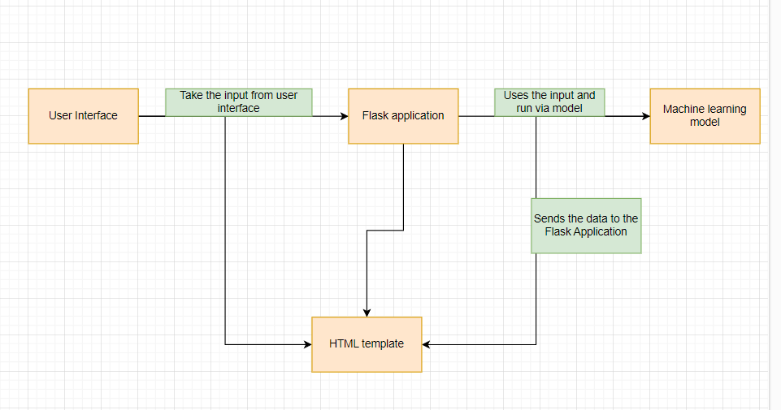***Figure 1: Architecture and data flow of the voice patient diary sample application*

**Reference: https://aws.amazon.com/blogs/industries/voice-applications-in-clinical-research powered-by-ai-on-aws-part-1-architecture-and-design-considerations/**

**6. PROJECT PLANNING & SCHEDULING: -**

**Project Planning Phase**

**Project Planning Template (Product Backlog, Sprint Planning, Stories, Story points)**

|  |  |
| --- | --- |
| Date | 19 September 2023 |
| Team ID | **593090** |
| Project Name | |  | | --- | | TrafficTelligence: Advanced Traffic  Volume Estimation with Machine Learning | |  | |
| Maximum Marks | 8 Marks |

**Product Backlog, Sprint Schedule, and Estimation (4 Marks)**

Use the below template to create product backlog and sprint schedule

|  |  |  |  |  |  |  |
| --- | --- | --- | --- | --- | --- | --- |
| **Sprint** | **Functional**  **Requirement (Epic)** | **User Story**  **Number** | **User Story / Task** | **Story Points** | **Priority** | **Team**  **Members** |
| Sprint-1 | Project setup &  Infrastructure | USN-1 | USN-1 Set up the development environment with the required tools and frameworks to start the advanced traffic volume estimation project. | 1 | High | Prince Raj  Hanut Bhatt |
| Sprint-1 | development  environment | USN-2 | USN-2 Gather a diverse dataset containing different types of holidays in a year (Durga Puja, Diwali, Chath Puja) for training the machine learning model. | 2 | High | Prince Raj  Hanut Bhatt |
| Sprint-2 | Data collection | USN-3 | USN-3 Preprocess the collected dataset by removing the outliers and splitting it into training and testing or validation sets. | 2 | High | Prince Raj |
| Sprint-2 | data preprocessing | USN-4 | USN-4 Explore and evaluate different machine learning architectures to select the most suitable model for advanced traffic volume estimation project. | 3 | High | Ayush Jha  Prince Raj |
| Sprint-3 | model development | USN-5 | USN-5 train the machine learning model using the pre-processed dataset and monitor its performance on the validation set. | 4 | High | Ayush Jha |
| Sprint-3 | Training | USN-6 | USN-6 implementing the hyperparameter tuning technique to improve the model's robustness and accuracy. | 6 | Medium | Hanut Bhatt  Prince Raj |
| Sprint-4 | model deployment & Integration | USN-7 | USN-7 deploy the trained machine learning model as a web service to make it accessible for advanced traffic volume estimation project. integrate the model's API into a user-friendly web interface for users and receive advanced traffic volume estimation results | 1 | Medium | Prince Raj  Hanut Bhatt  Ayush Jha |
| Sprint-5 | Testing & quality assurance | USN-8 | conduct thorough testing of the model and web interface to identify and report any issues or bugs. fine-tune the model | 1 | Medium | Prince Raj  Ayush Jha |

**Project Tracker, Velocity & Burndown Chart: (4 Marks)**

|  |  |  |  |  |  |  |
| --- | --- | --- | --- | --- | --- | --- |
| **Sprint** | **Total Story**  **Points** | **Duration** | **Sprint Start Date** | **Sprint End Date**  **(Planned)** | **Story Points**  **Completed (as on Planned End Date)** | **Sprint Release Date**  **(Actual)** |
| Sprint-1 | 20 | 2 Days | 10 Nov 2023 | 12 Oct 2023 | 20 | 10 Nov 2022 |
| Sprint-2 | 20 | 1 Days | 13 Nov 2023 | 14 Nov 2023 | 10 | 13 Nov 2023 |
| Sprint-3 | 20 | 3 Days | 15 Nov 2023 | 18 Nov 2023 | 10 | 15 Nov 2023 |
| Sprint-4 | 20 | 2 Days | 19 Nov 2023 | 21 Nov 2023 | 20 | 19 Nov 2023 |

**Velocity:**

Imagine we have a 10-day sprint duration, and the velocity of the team is 20 (points per sprint). Let’s calculate the team’s average velocity (AV) per iteration unit (story points per day)



AV=29/20 = 1.45

**Burndown Chart:**

A burn down chart is a graphical representation of work left to do versus time. It is often used in agile software development methodologies such as Scrum. However, burn down charts can be applied to any project containing measurable progress over time.

**https://www.visual-paradigm.com/scrum/scrum-burndown-chart/**

**https://www.atlassian.com/agile/tutorials/burndown-charts**

**Reference:**

**https://www.atlassian.com/agile/project-management**

**https://www.atlassian.com/agile/tutorials/how-to-do-scrum-with-jira-software**

**https://www.atlassian.com/agile/tutorials/epics**

**https://www.atlassian.com/agile/tutorials/sprints**

**https://www.atlassian.com/agile/project-management/estimation**

**https://www.atlassian.com/agile/tutorials/burndown-charts**

**Project Design Phase-II**

**Technology Stack (Architecture & Stack)**

|  |  |
| --- | --- |
| Date | 19 September 2023 |
| Team ID | **593090** |
| Project Name | |  | | --- | | TrafficTelligence: Advanced Traffic  Volume Estimation with Machine Learning | |  | |
| Maximum Marks | 4 Marks |

**Technical Architecture:**

The Deliverable shall include the architectural diagram as below and the information as per the table1 & table 2 **Example: Order processing during pandemics for offline mode**

**Reference: https://developer.ibm.com/patterns/ai-powered-backend-system-for-order-processing-during-pandemics/**

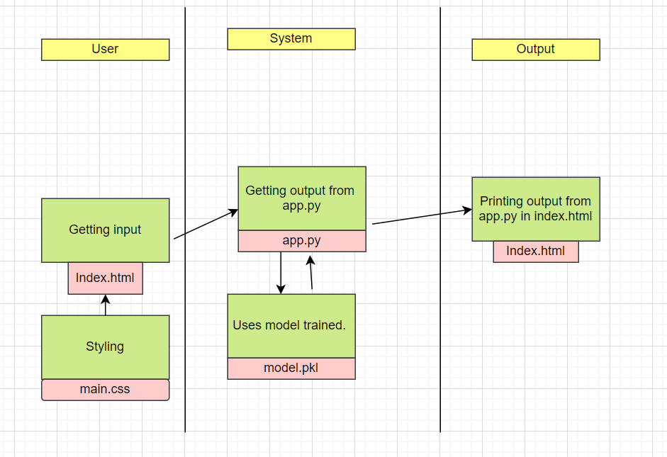**Guidelines:**

1. Include all the processes (As an application logic /Technology Block)

2. Provide infrastructural demarcation (Local / Cloud)

3. Indicate external interfaces (third party API’s etc.)

4. Indicate Data Storage components / services

5. Indicate interface to machine learning models (if applicable)

**Table-1: Components & Technologies:**

|  |  |  |  |
| --- | --- | --- | --- |
| **S.No** | **Component** | **Description** | **Technology** |
| 1. | User Interface | How user interacts with application e.g.  Web UI or how the user finds out the output from the model after giving the inputs etc. | HTML, CSS. |
| 2. | Application Logic-1 | Logic for a process in the application | Python |
| 3 | File Storage/Data | File storage requirements for storing the data | Local System. |
| 4 | Framework | Used to Create a web Application, Integrating Frontend and Back End | Python Flask |
| 5 | Machine Learning Model | The Purpose of Machine Learning Model is to predict the traffic volume on a particular day. | Traffic detection Model, etc. |
| 6 | Infrastructure (Server / Cloud) | Application Deployment on Local System / Cloud Local Server Configuration:  Cloud Server Configuration: | GitHub, Local, |

**Table-2: Application Characteristics:**

|  |  |  |  |
| --- | --- | --- | --- |
| **S.No** | **Characteristics** | **Description** | **Technology** |
| 1. | Open-Source Frameworks | List the open-source frameworks used | Python’s Flask |
| 2. | Security Implementations | List all the security / access controls implemented, use of firewalls etc. | e.g., SHA-256, Encryptions, IAM Controls, OWASP etc. |
| 3. | Scalable Architecture | Justify the scalability of architecture (3 – tier, Micro-services) | Technology used |

|  |  |  |  |
| --- | --- | --- | --- |
| **S.No** | **Characteristics** | **Description** | **Technology** |
| 4. | Availability | Justify the availability of application (e.g., use of load balancers, distributed servers etc.) | Technology used |
| 5. | Performance | Design consideration for the performance of the application (number of requests per sec, use of Cache, use of CDN’s) etc. | Technology used |

**References:**

**https://c4model.com/**

**https://developer.ibm.com/patterns/online-order-processing-system-during-pandemic/**

**https://www.ibm.com/cloud/architecture**

**https://aws.amazon.com/architecture**

**https://medium.com/the-internal-startup/how-to-draw-useful-technical-architecture-diagrams-2d20c9fda90d**

**Project Development Phase**

**Model Performance Test**

|  |  |
| --- | --- |
| Date | 19 September 2023 |
| Team ID | **593090** |
| Project Name | |  | | --- | | TrafficTelligence: Advanced Traffic  Volume Estimation with Machine Learning | |  | |
| Maximum Marks | 10 Marks |

**Model Performance Testing:**

Project team shall fill the following information in model performance testing template.

|  |  |  |  |
| --- | --- | --- | --- |
| **S.No.** | **Parameter** | **Values** | **Screenshot** |
|  | Model Summary | Null Values  Number of null values in temp-53  Number of null values in rain - 2  Number of null values in snow-12  Number of null values in weather-49  No outlier values  The counter value-  Counter({'Clouds': 15144, 'Clear': 13383, 'Mist': 5942, 'Rain': 5665, 'Snow': 2875, 'Drizzle': 1818, 'Haze': 1359, 'Thunderstorm': 1033, 'Fog': 912, nan: 49, 'Smoke': 20, 'Squall': 4})  Number of values in y_test- 9641  R2 score for RandomForestClassifier-97.7372  Mean Squared Error for RandomForestClassifier-798.4415 |  |
|  | Accuracy | Training Accuracy - 97.7372  Validation Accuracy -78.9658 |  |
| 3. | Confidence Score (Only Yolo Projects) | Class Detected -   Confidence Score - |  |

**Project Development Phase**

**Model Performance Test**

|  |  |
| --- | --- |
| Date | 19 September 2023 |
| Team ID | **593090** |
| Project Name | |  | | --- | | TrafficTelligence: Advanced Traffic  Volume Estimation with Machine Learning | |  | |
| Maximum Marks | 10 Marks |

**Model Performance Testing:**

Project team shall fill the following information in model performance testing template.

|  |  |  |  |
| --- | --- | --- | --- |
| **S.No.** | **Parameter** | **Values** | **Screenshot** |
|  | Metrics | **Regression Model:** MAE -617.6653 , MSE -**798.4415** , RMSE - , R2 score -**97.7372**  **Classification Model:** Confusion Matrix - , Accuracy Score-77.8966 & Classification Report - |  |
|  | Tune the Model | Hyperparameter Tuning - GradientBoostingRegressor  GridSearchCV Validation Method - train and test split method |  |

**OUTPUT SCREEN: -**

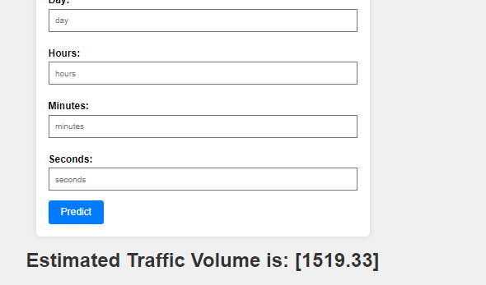

**10. ADVANTAGES & DISADVANTAGES**\*\*

**Advantages: -**

10.1 Efficient Traffic Management:

- TrafficTelligence facilitates efficient traffic management by providing real-time insights into traffic volume, allowing authorities to make data-driven decisions.

10.2 Preventive Measures:

- Early alerts and pattern recognition enable authorities to take preventive measures, reducing the likelihood of severe traffic issues, accidents, and rule violations.

10.3 Optimized Urban Planning:

- Accurate traffic volume predictions contribute to optimized urban planning and infrastructure development, leading to better allocation of resources.

10.4 User-Friendly Interface:

- The system's user-friendly interface enhances accessibility, allowing various stakeholders to understand and interpret traffic data easily.

10.5 Integration with Existing Systems:

- TrafficTelligence can seamlessly integrate with existing traffic management systems, ensuring a smooth transition and cooperation with established infrastructure.

**Disadvantages:**

10.6 Data Dependency:

- The accuracy of TrafficTelligence is heavily dependent on the quality and availability of data. Inaccurate or incomplete data may affect the system's performance.

10.7 Initial Implementation Costs:

- The implementation of advanced AI-ML systems may involve significant initial costs for infrastructure, training, and technology adoption.

10.8 Privacy Concerns:

- The collection and analysis of real-time traffic data may raise privacy concerns among the public. Addressing these concerns is crucial for the successful implementation of TrafficTelligence.

10.9 *Technical Challenges:*

- Developing and maintaining sophisticated ML models involves addressing technical challenges such as model updates, adapting to changing traffic patterns, and ensuring ongoing accuracy.

**11. CONCLUSION**

In conclusion, TrafficTelligence represents a significant advancement in addressing traffic-related challenges. By leveraging AI-ML capabilities, the system provides a holistic approach to traffic volume estimation, pattern recognition, and early warning systems. The benefits include enhanced traffic management, optimized urban planning, and improved decision-making for authorities. However, challenges such as data dependency, initial implementation costs, and privacy concerns must be carefully considered and addressed for the successful deployment of TrafficTelligence.

**12. FUTURE SCOPE**

The future scope of TrafficTelligence involves continuous improvement and expansion:

12.1 Enhanced Prediction Accuracy:

- Continuously refine and update ML models to improve prediction accuracy by incorporating more diverse data sources and advanced algorithms.

12.2 Integration with Smart Cities:

- Explore integration possibilities with broader smart city initiatives to create a comprehensive urban management ecosystem.

12.3 AI-Driven Traffic Control:

- Move towards AI-driven traffic control systems that dynamically adjust traffic signals and routes based on real-time conditions.

12.4 Predictive Analytics for Infrastructure Development:

- Extend the system's capabilities to provide predictive analytics for long-term infrastructure development and city planning.

**13. APPENDIX: -**

Github Link: - <https://github.com/smartinternz02/SI-GuidedProject-613123-1700294375>  
  
Video Demo: -

<https://drive.google.com/file/d/1Jxnw5gSpmvsIIxlklCBAFd5_JD4AaFSO/view>